- Sketch the functions using steps procedures.
F(x) = 3 sin (4x)
Period = 2π/4 = π /2 divide 4 = π/8 fundamental cycles
0 ≤ π/8 ≤ 2π

x | y
π/8 | 3
3 π/8 | -3
5 π/8 | 3
7 π/8 | -3
9 π/8 | 3
11 π/8 | -3

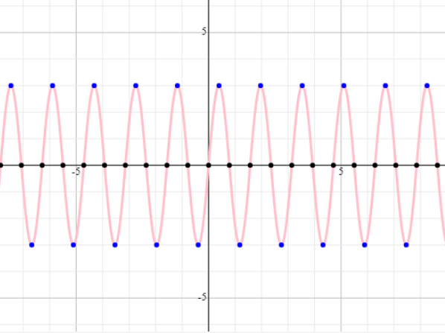

b. f(x) = 2 sin (3x-π)

Period = 2π/3 divide 4 = π/6 fundamental cycles

0 ≤ π/6 ≤ 2π

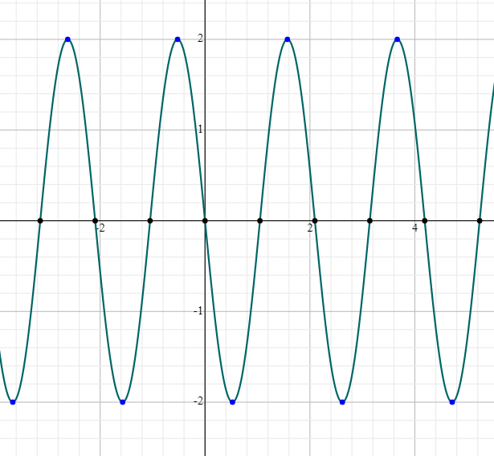

C. f(x) = -1/2 cos (x-π/2) +1

Period is 2π divided by 4 = ½ π fundamental cycles
0 ≤ π/2 ≤ 2π

x | y
0 | 1
π/2 | 1/2
3 π/2 | 3/2
5 π/2 | 1/2
7 π/2 | 3/2
9 π/2 | 1/2

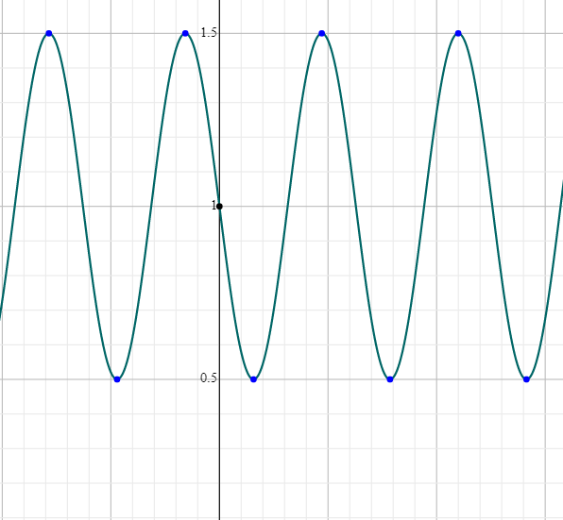

D. f(x) = cos (3x)
Period = 2π/3 divide 4 = 2π/12 fundamental cycle
0 ≤ π/6 ≤ 2π

x | y
0 | 1
π/3 | -1
2 π/3 | 1
π | -1
4 π/3 | 1
5 π/3 | -1

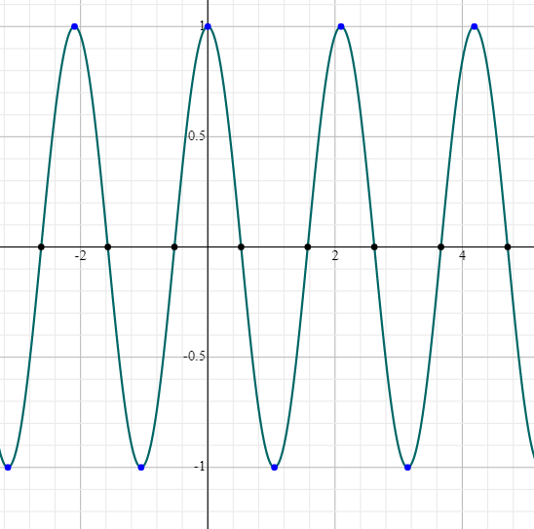

E ) y= 3sin( 2 πx- π)-1
Period = 1 divide 4 = 1 /4 fundamental cycles

0 ≤ ¼ ≤ 2π
x | y
0 | -1
1/4 | -4
3/4 | 2
5/4 | -4
7/4 | 2
9/4 | -4

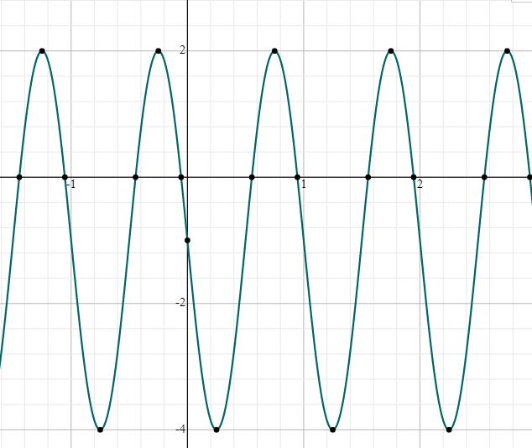

F) y= -2 cos (πx + 2π/3)

Period = 2 divide 4 = 1/6 fundamental cycle
0 ≤ 1/6 ≤ 2π
x | y
0 | 1
1/3 | 2
4/3 | -2
7/3 | 2
10/3 | -2
13/3 | 2

